We spoke about data arch a lot on Tuesday

Now we are gonna talk aboutL

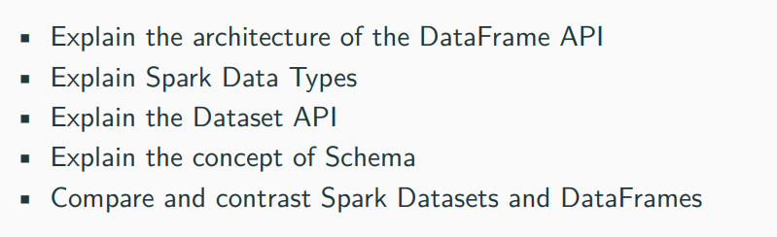

We are gonna do ingestion, transformation.

We will migrate to bigger datasets, more of cloud structure in the end..

**We are gonna talk about nature of apache spark:**

**History of apache:**

Spark is a project house in Apache foundation. Apache foundation came from a very 1st webserver which was released from Netscape (this doesn’t exist anymore, but Netscape became ground for firefox mozilla) but they released 1st webserver we started to use it to u-commerce, host websites, take credit cards, not ready for primetime so there were many patches submitted,, so it became known as a patchy server…..later changed as apache server

**Spark:**

Spark is a project sponsored by them. It came out of usc, they donated the code. There is a commercial company called data bricks that founder when founded it, they offer commercial services and custom features on top of spark but the source code is completely open and we can use if. We can run on our spark clusters.

The documentations is here:

[**https://spark.apache.org/**](https://spark.apache.org/)

we are gonna spend our entire time this sem coding using this link reading api’s in this

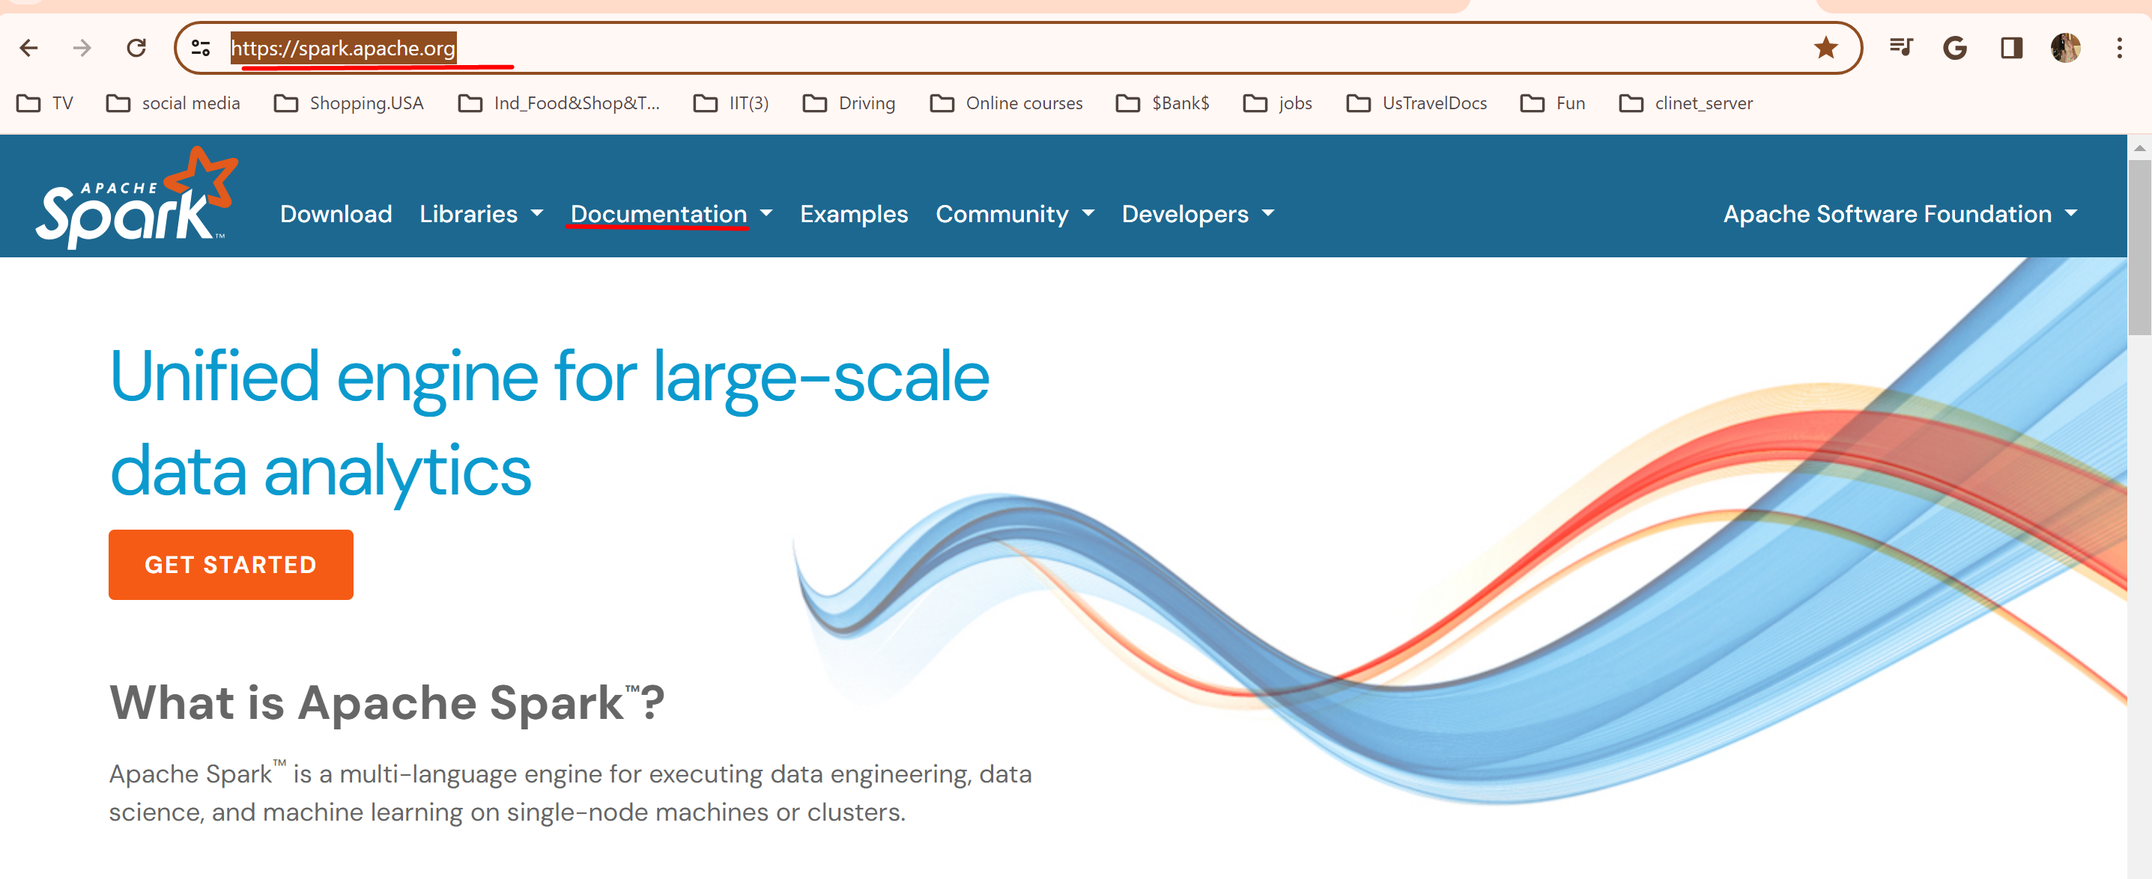

**Review from chapt1 and 2**

**- Spark session,**

**-cluster manager, spark executor**

**-4 deployment modes (mostly we use 2 now a days single node cluster and local cluster spark cluster)**

**-partitions**

**-actions vs transformations. (lazy loading takes place on tranf)**

**- its really just taking sql concepts ..think about in sql…**

**-an action go and gets something**

**A transf will re-arranges what we have.**

**-prof soke something about sbt(prev lab1) and the issues we got while running the scala application**

**Let’s talk about spark:**

Spark started with something called **RDD (a datatype**) ~ **Resilient distributed datasets**

This is for historical purpose and we don’t use rdd anymore

Basically this is what lies at the bottom of the spark

**Dataset**: an excel table without relations. Columns. its types. self-contained table of data

What spark does it adds some secret sauce under the hood to allow that 1 table to distribute in multiple systems. So that you can calculate independently on columns and set of rows without having to go sequentially.

If we have single system we have to go line by line by line …………

But Spark spreads it out with distributed processing and then they re-assemble the results….this is called **parallelism.**

in theory we can be able to gain a lot in parallel, each of these **jobs** are independent, if one failes the other jobs goes ..dont stop

**JOBS:** the queries here we run

SO now no RDD’s ..we have data frames and datasets (extracted from RDD)

**Technically there is no such thing as DataFrame …**they do exist in python and r but not in spark

Everything in spark complies down to java so **in spark/reality df are nothing but datasets**.

Data sets in java and scala.

We will do lil more develop in scala.

We are gonna talk about df:

Everything on planet deals with df. A df is the default dataset. Set of data.

The way we are gonna work . do our analysis and pass our data b/w the functions is with df’s

Support Languages by default:



If we wanna do it in Hadoop we are gonna do it java and we have to use mapreduce . there was no sql. They built a whole bunch of pluggin son top of it and convert it in to sql database

In r we cant build websites and all but we can do statistics and maths

Scala is pythonic java and it supports raw SQL

We can do. select in python object or spark object and that’s like writing select from tables.

We can add plugins to spark like c sharp

So spark compiles it to java…whatever code we write..and then runs the app

Running takes time. But its worth bcoz we writing in our language

Spark has built in **streaming libraries** which will do streaming data. It will consume it and it will operate on df’s

SO WHAT IS DF?

Is a common datatype that spark uses in data analytics and machine learning. It’s a kind of standard way to distribute and collect data

Before df,,, we have objects

This is an ex of spark project In the book:

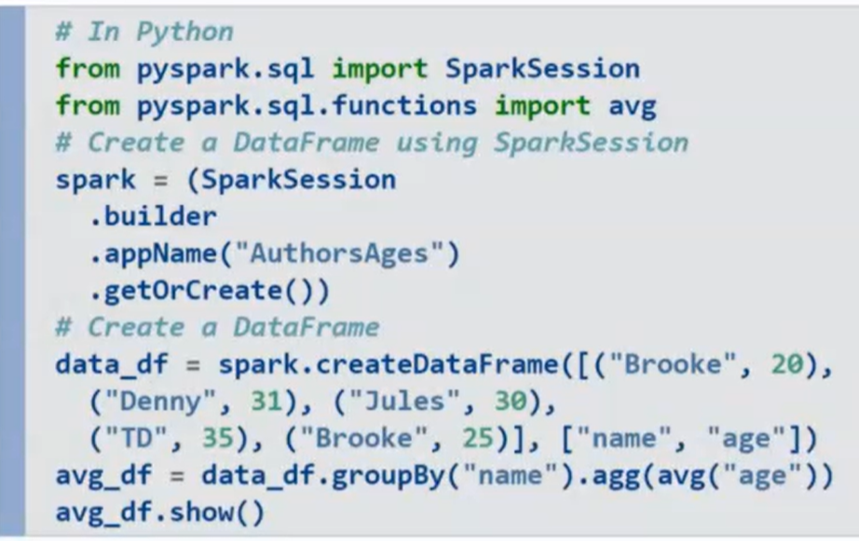

**Explantion of the code:**

We are not reading any values from a file here

We are just hardcoding a df ourselves

There is a function called create a df

We imported the spark session object

We also importing some sql functions like avg

And we had a spark session object called spark

And here is our df (data_df) we don’t declare a df ..python and scala don’t have data types but out of convention they append this df…so that if some one else look at your code, they will get to know “oh this is probably a df”

its not a bad habit..its not requires. But it will help a lot in troubleshooting

its go into the spark object and it creates a df and a series of values **….[.name, age**] this is our dataframe.

So This data_df constructs a data frame for us….NOTE that this will not be constructed right away

When does it constructs it:

From the next one:

Avg_df + original_df. Groupby

Groupby is transformation

We have to go query the data in this line

And then it executes it in action (showme)

The agg(avg(age)) ………..it aggregates on avg age what will this code do?

For ex in the above code we have Broke twice with diff ages

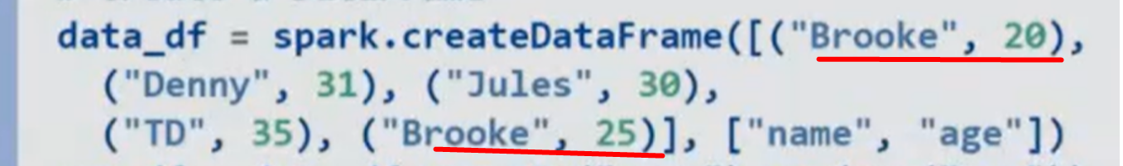

So what does this agg(avg(age)) is gonna do to this?

Aggregates based on the names and averages the age if the same is more than 1

So her we may get (Broke , 23) something like that ……………………………….20 + 25 / 2 = 45/2 =22.5

The person names Broke and his avg age is 23 yrs old

And then we hit show and it all executes….its gonna take some time..here its just 3 lines so it may take less time..

But if our dataset is gonna get 10 tb of data…it might take a lil bit of more time to distribute that

**SO DON’T GET SPOILED BY THIS ABOVE SIMPLE EXAMPLE… THE REAL CODE (JOB) MIGHT BE VERY LONG AND IT MAY GET LONGER DATA ….SO ITS GONNA TAKE VERY LONGER TIME.**

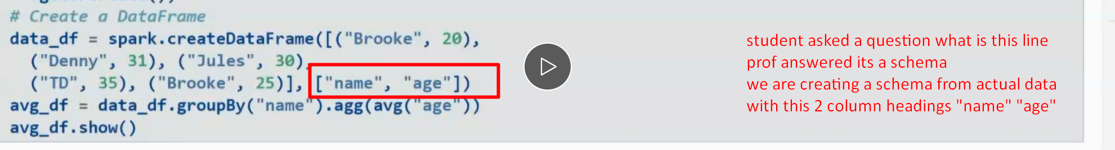

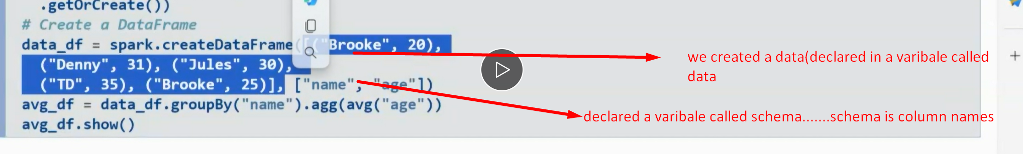

Here “age” is int datatype but its in double quotes?

Column names have to be in double quotes

We don’t need to define data types for this schema(column names) by default the infer schema is turned on (true by default)

**From 29. 10 min:**

Spark 3.2 ,,,,now we are in spark 3.5 ….it supports pandas

Originally spark used to copy Pandas

But now we can use pandas data types directly in spark

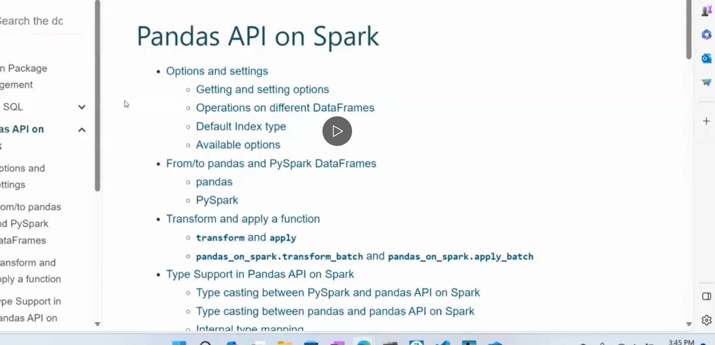

We will talk about more on this in coming weeks

**Dataframes are immutable**

You cant assign new value back,….it will create a memory space

Spark Dataframe supports all in-language data types like:

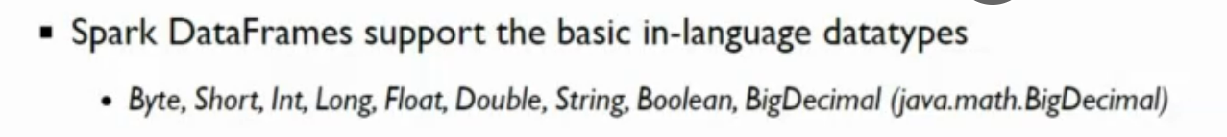

But unfortunately our data is not one of these things..some time it could be one of those above but some times it could be more complicated data types like:

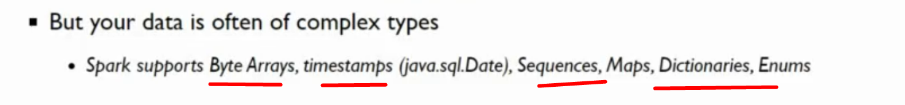

Timestamps are awful

There is support for these diff datatypes.

Withing spark we need to import those libraries specifically

But you cant support other types of data bcoz oftentimes the data we inherit from a database could be an object

Student asked doubt : spark doesn’t support char data type?

Prof answer : yes it is hided under string datatype

**DATAFRAMES:**

Spelled with 1 word – D or F

A df must have a **schemas**

**These schemas can be defined in 3 ways**

**1.auto infer schema** - hey spark do your best…. This is fine with lil bit of data …or the data you are sure you know…the datatypes of columns and all…….

But once you have more records,,,you physically have to read….you probably don’t want to do that

**2. deifine programmatically: in scala and python**

**3. By DDL:** a lot simpler but not programmatic

**Here is the ex of defining schema progrmatically in scala and python:**

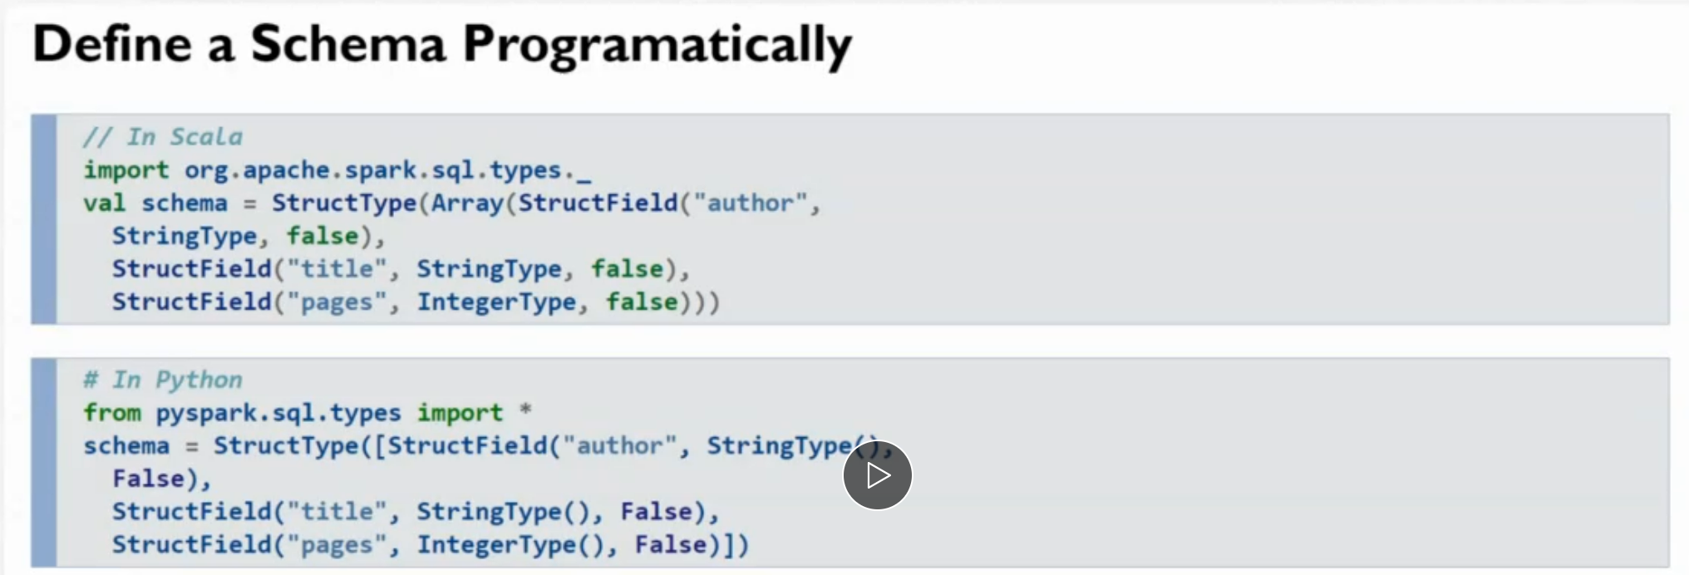

**Here is the explanation of code:**

Python doesn’t have arrays…lists and dictionaries are the collection data types.

Scala has arrays since its java

True and False are the true objects in python ..but they are still primitives in java so these will be primitives in scala too

In both of those…you are doing the same…..you’re creating a structure

Structure is like a proto object..its not an obj…but it functions.like an obj..it collects a bunch of data together in a single header that can be accessed.

So you have to declare these…this is how you create a schema…not top hard…..and then we declare the datatypes…

The tricky part comes when our field/column is time / timestamp….then we have tp declare it as a timestamp datatype

The book will show us how to do that

This is also schema in sql language

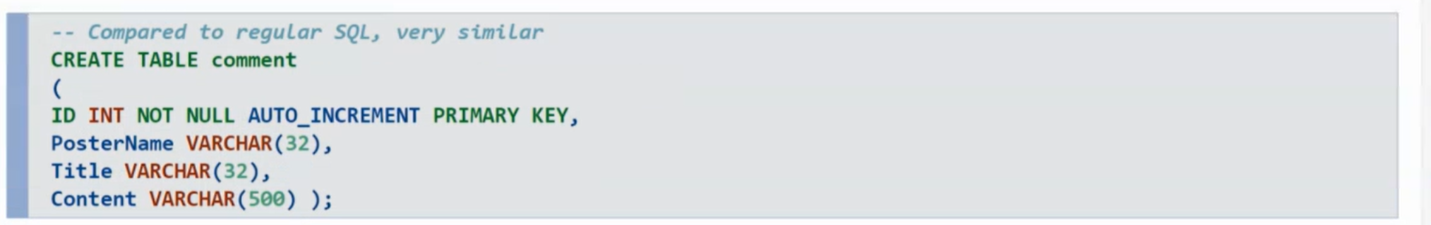

The above 2 are schemas in python and scala

**HERE IS HOW TO DO IN DDL:**

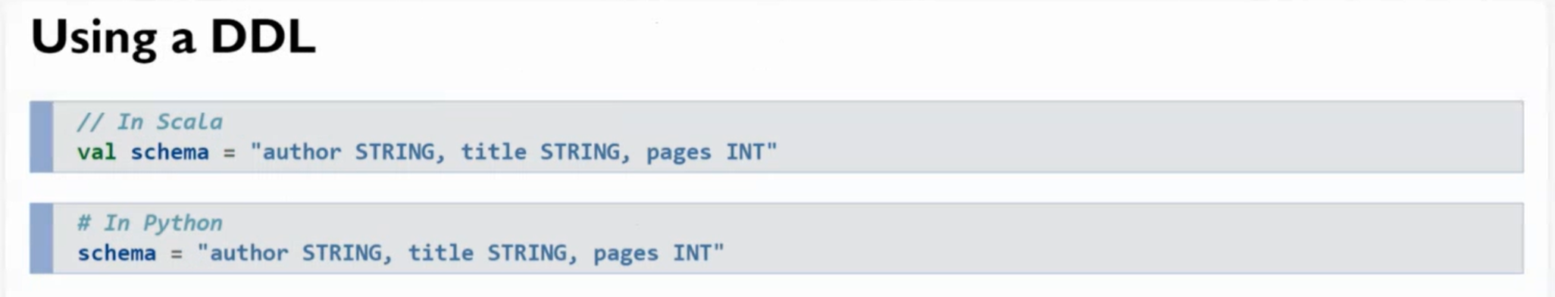

Whats the advantage of this way? It focuses more on the logic and less on the syntax

ANOTEHR unique thing about df is that each column acts an its own object and all the value in that column are attributes

We can operate on individual columns or take 2 columns and put them together for calculating here…we call them **bucketing**

**This is the feauture that normal sql table doesn’t have…sql cant split the columns up and separate them for processing…we need to take the whole column**

**If we want to get datasets…our data vframes are the collections of datasets with type dataset rows**

**Parquet –french _Partitioning:**

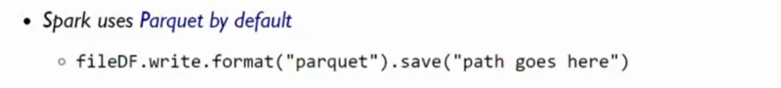

Is a binary format that allows us to partition for data…10 k records….we can chop it in to pieces of data without impacting the execution of the…

We cant cut json file and cut in it half….bcoz there are brackets that we need to keep…

Not also with excel file…is a binary format and has a structure around it

**But parquet is built for spark and its default…..So in the data engineering a lot of work we will do is converting the data sets into parquet format**

**And if you see the file size after converting…its compressed a lot and the size is very less**

**Bcoz these parque is in binary format..which means we can do compression**

**.txt .cvs .json . these are uncompressed…..you can open them up ..**

**But if you have 50 million record we cant open them up in our notepad…and we cant scroll down to 36 thoundth row/record to check…its impossible**

**So to make it more readable. SO WE NEED TO convert these files into binary format**

**We need to convert to parquet files … bcoz parquet by default in binary format.. and it does portioning…so the data can be ready here for the processing on the spark cluster**

**Example 3.6…its in the LearningSparkV2**

**FROM 38 min:**

**Lets take that code..compile and run it**

**And then we will switch over to the assignment**

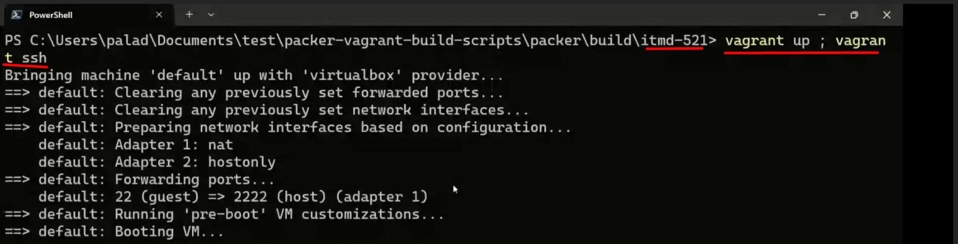

**Stud asked a doubt that in df every column is treated as an object right? So how do we query an entire row? Is it possible?**

**Yes**

**If we want to retrieve an entire row….**

**How? Using the select statement..**

**To filter a particular row…?**

**WE SET A CONDITION**

**use where..vlaue = x (exact same way as sql)**

**you can do it raw sql**

**or**

**you can use programmatically by .select .filter function on python objects**

**ex:**

**spark .select .filter and you put the categories in there**

**select would be which columns would you want**

**filter would be whats your filter condition (avg…or name is John or id = 001 like that)**

lets go into chapter 3:

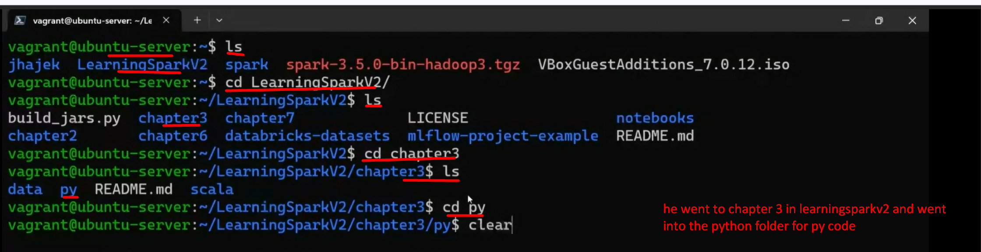

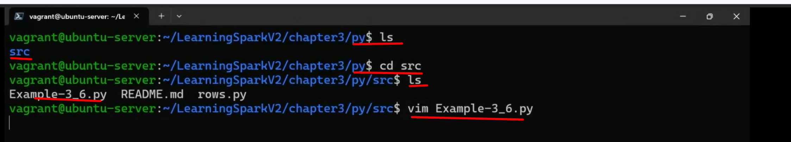

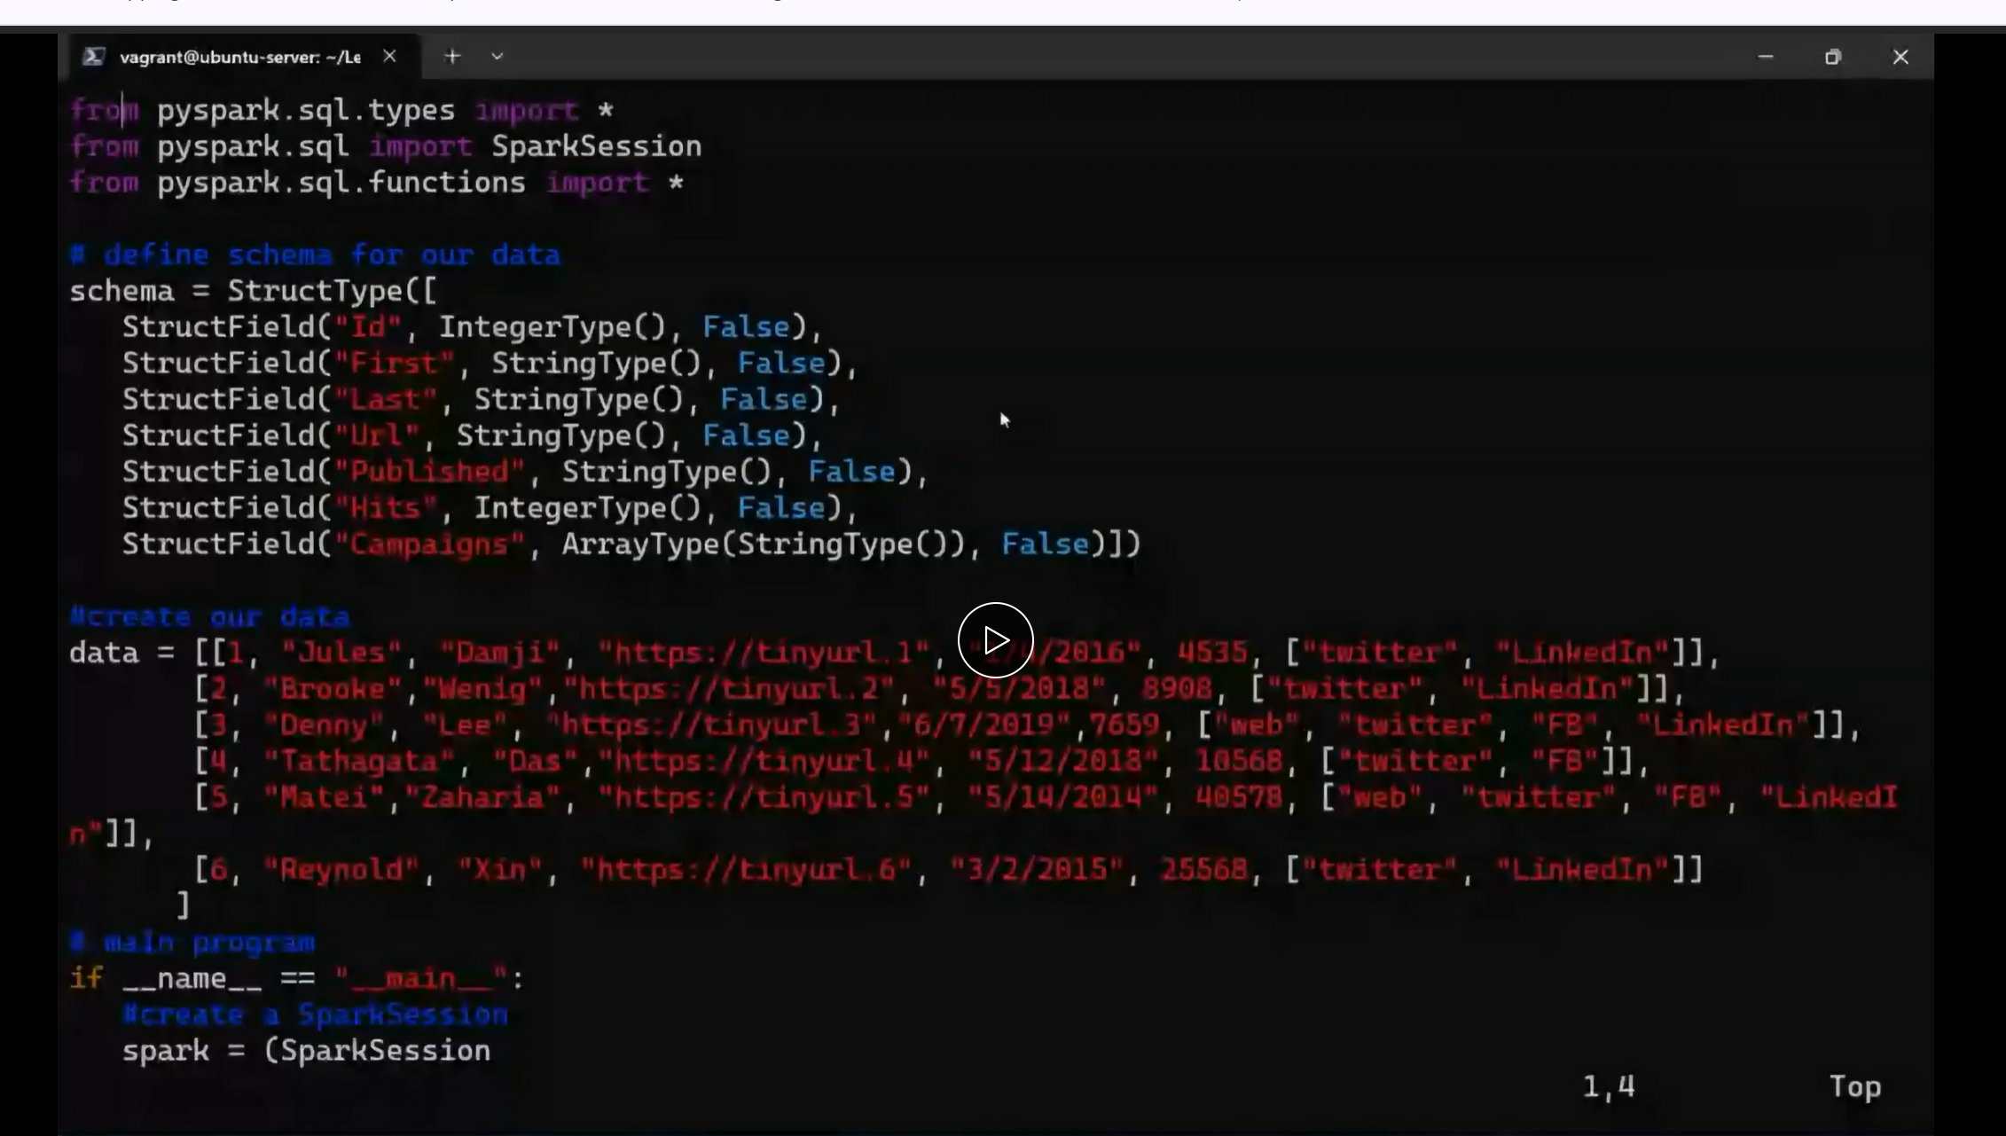

This is an ex of schema

This is hardcoding the data set /// data…the customer report for a social media company

This is the python code (((((if im confusing….prof went in to py/src folder) after this he said he will go into scala folder and scala code

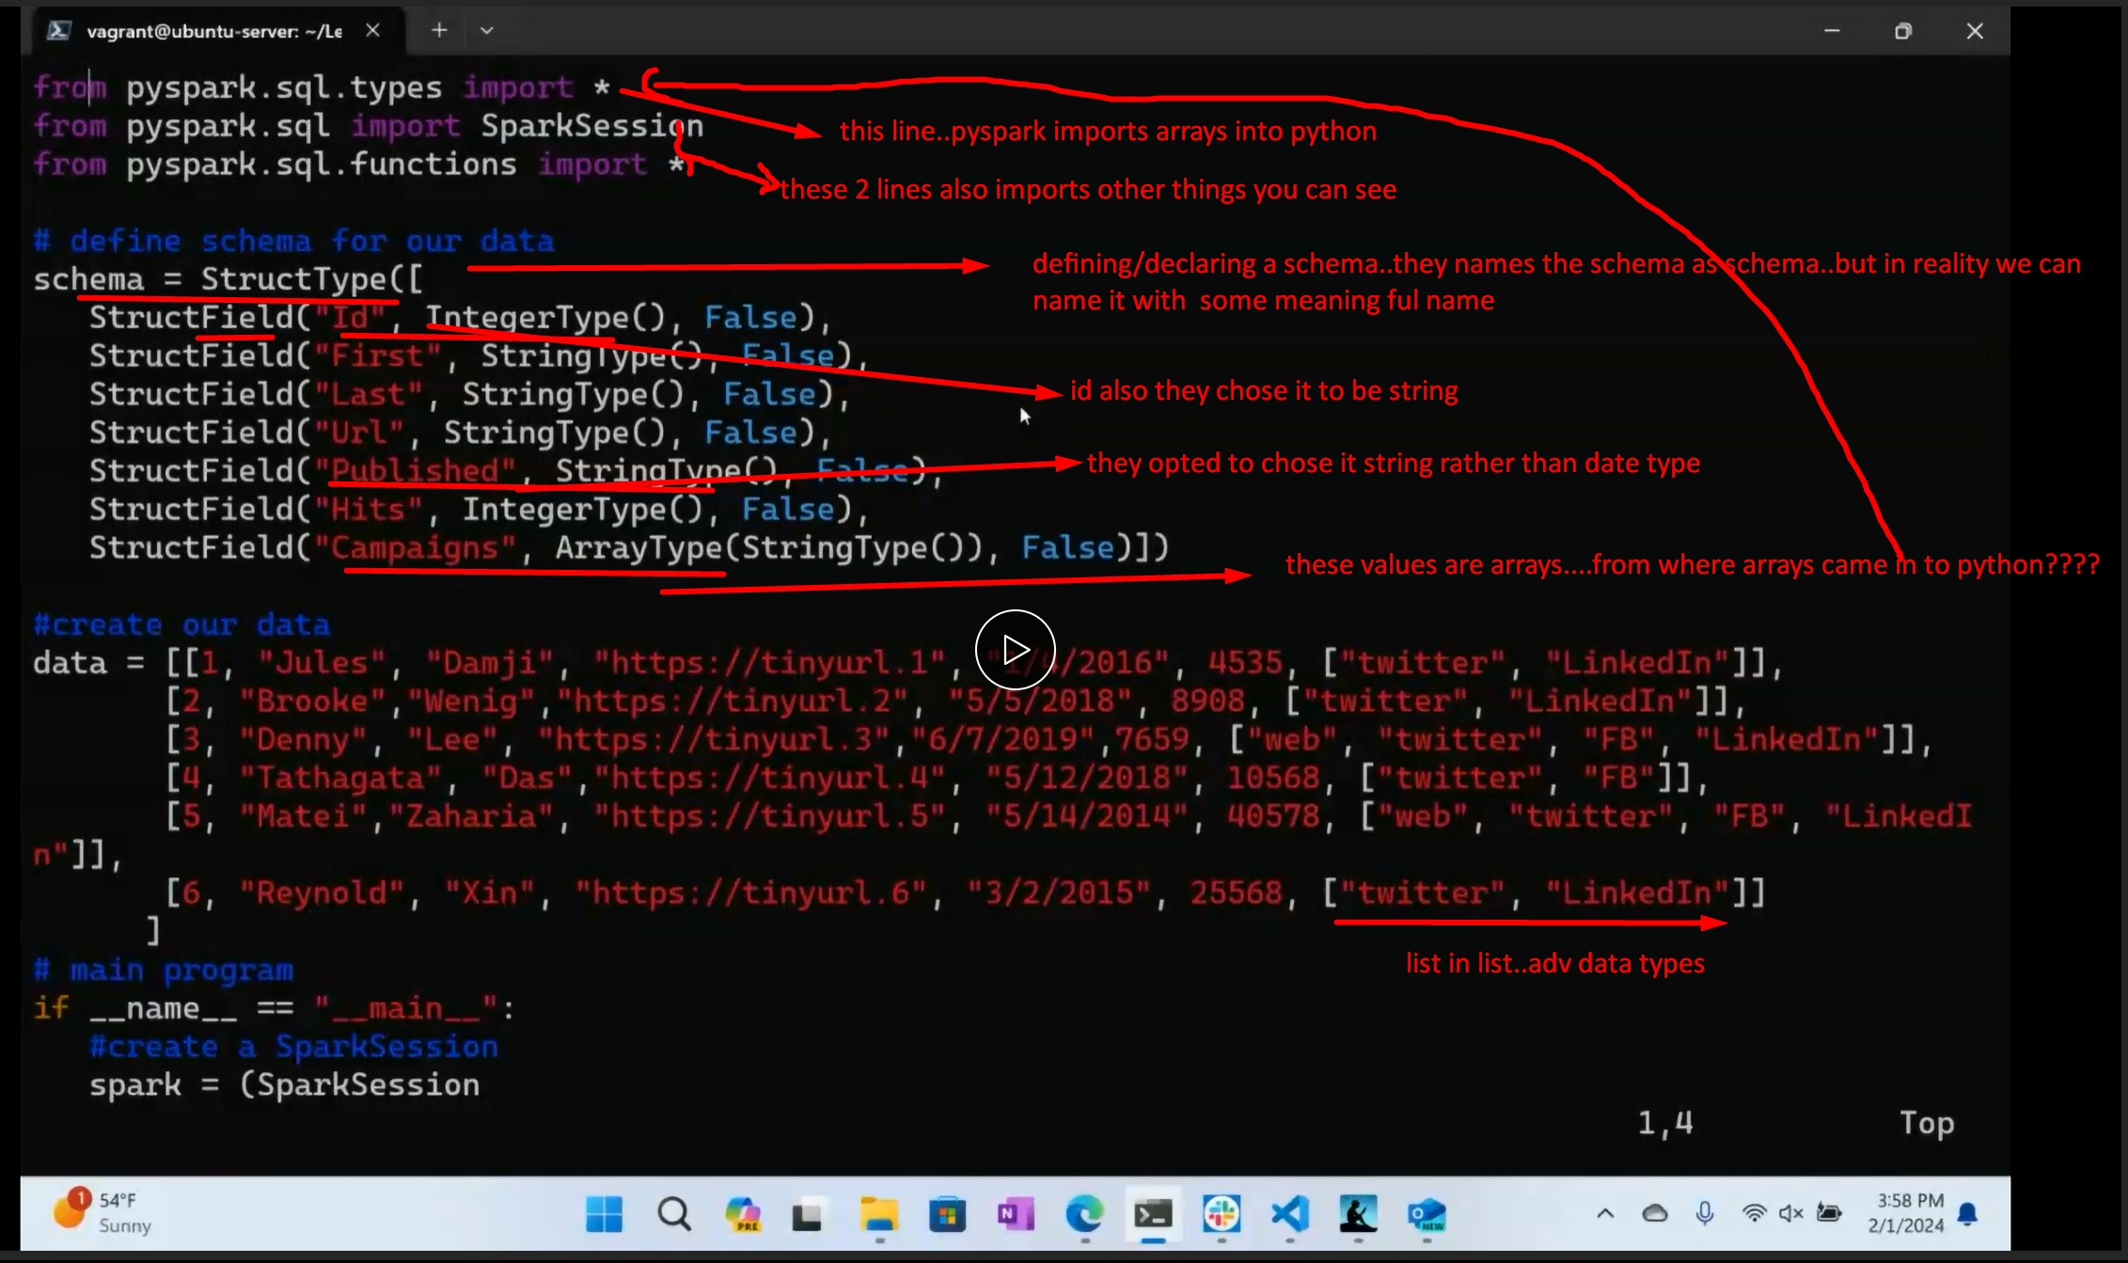

Every dataframe knows its own schema

So functon called printSchema() which will print out the schema

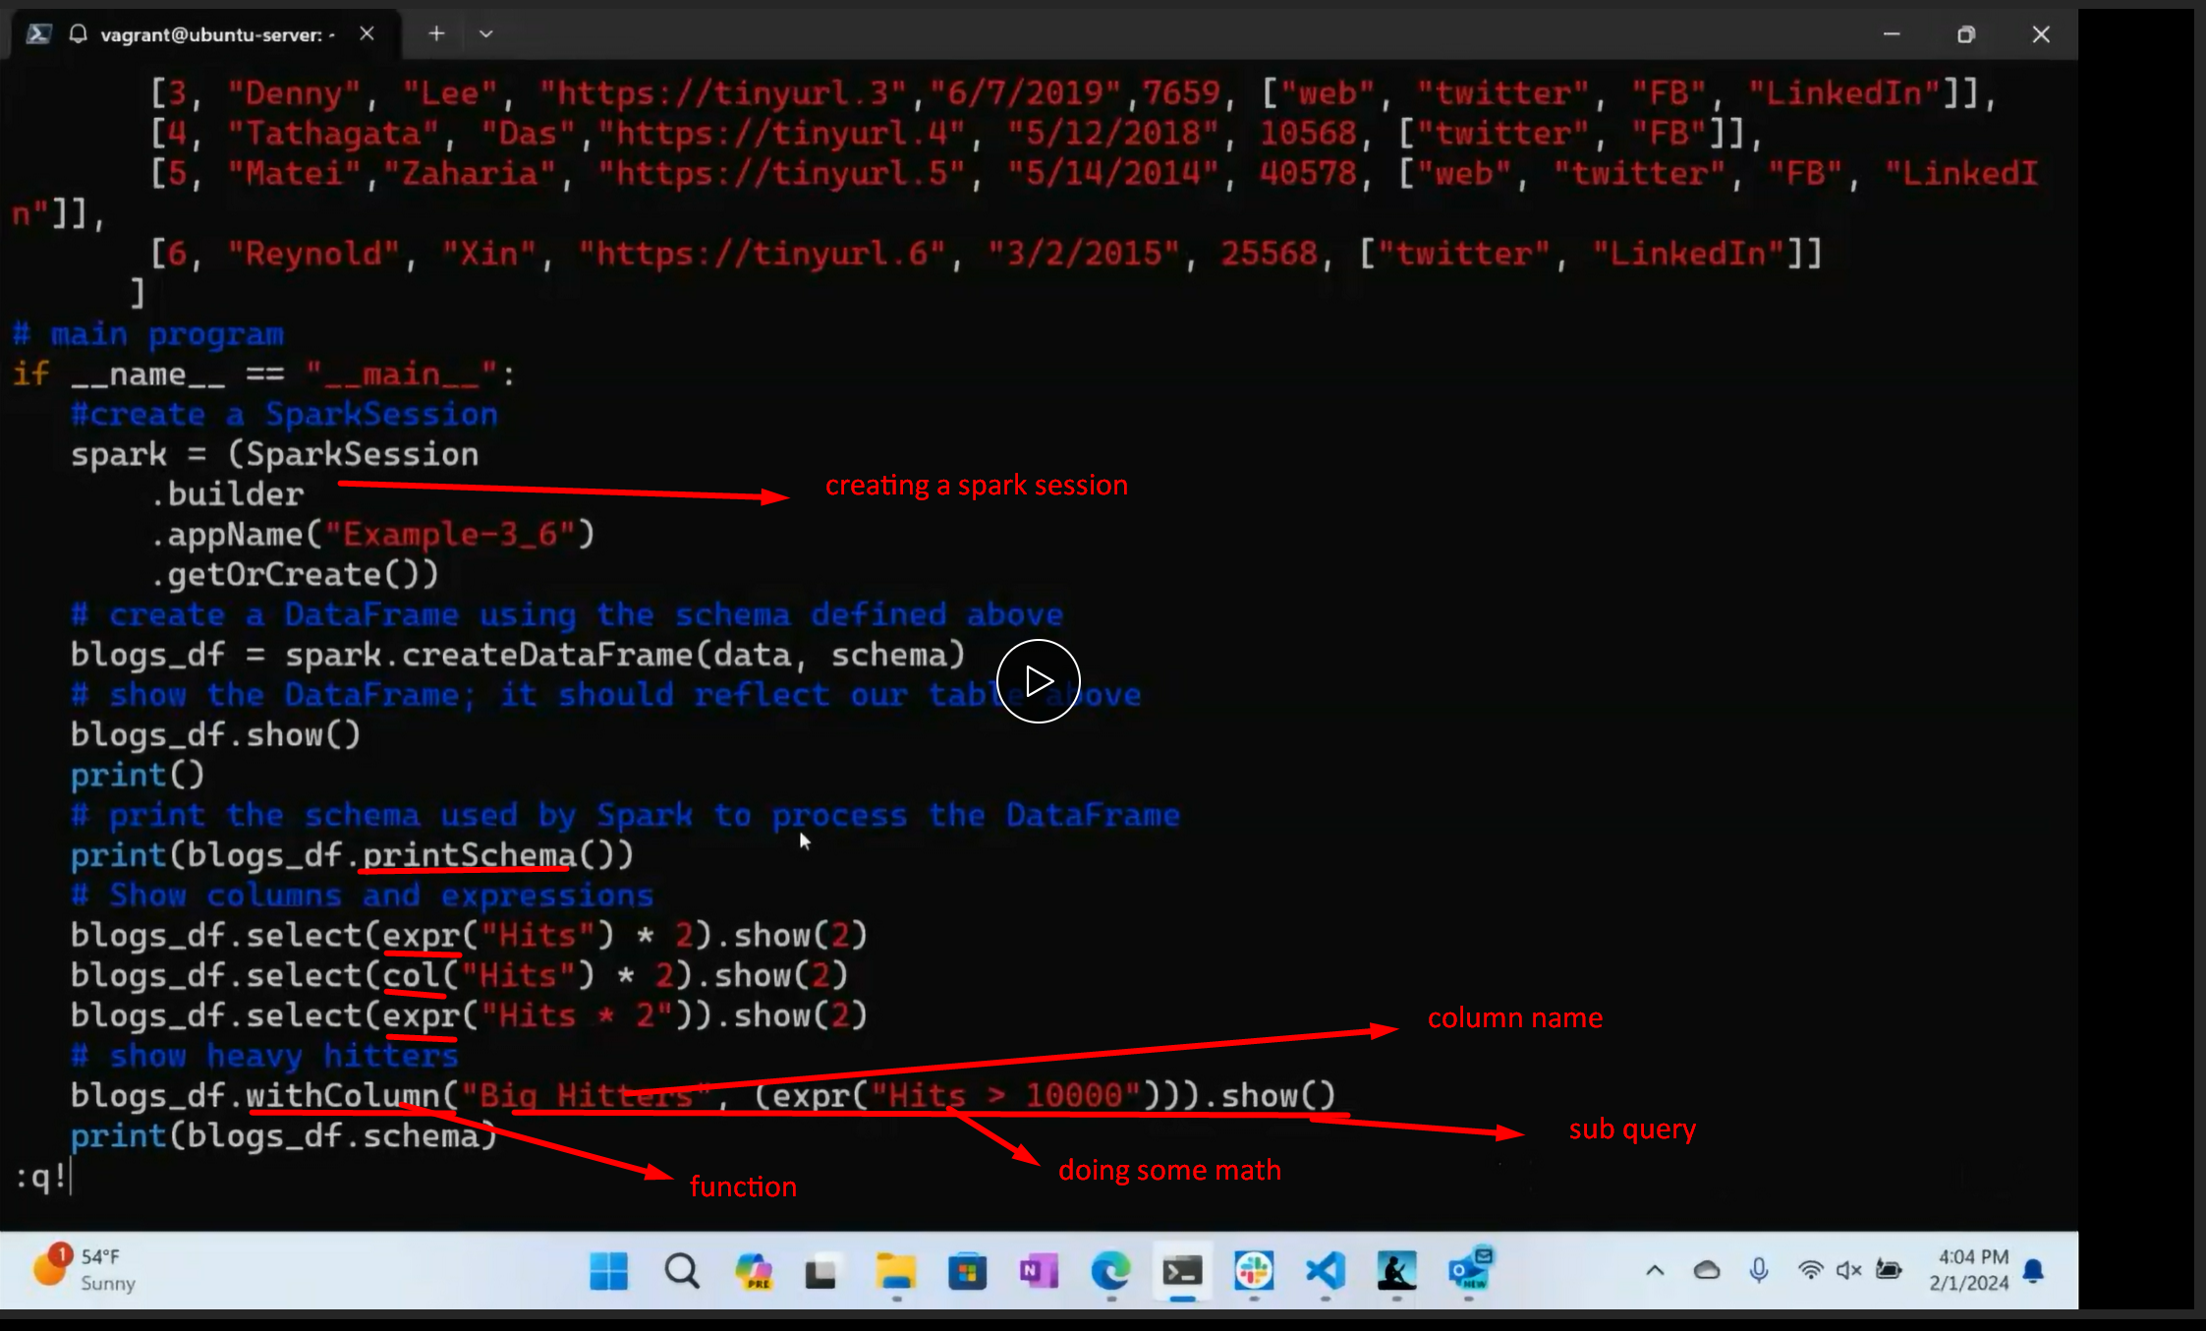



Lets run this python code python application

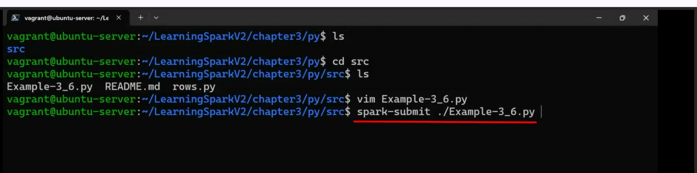

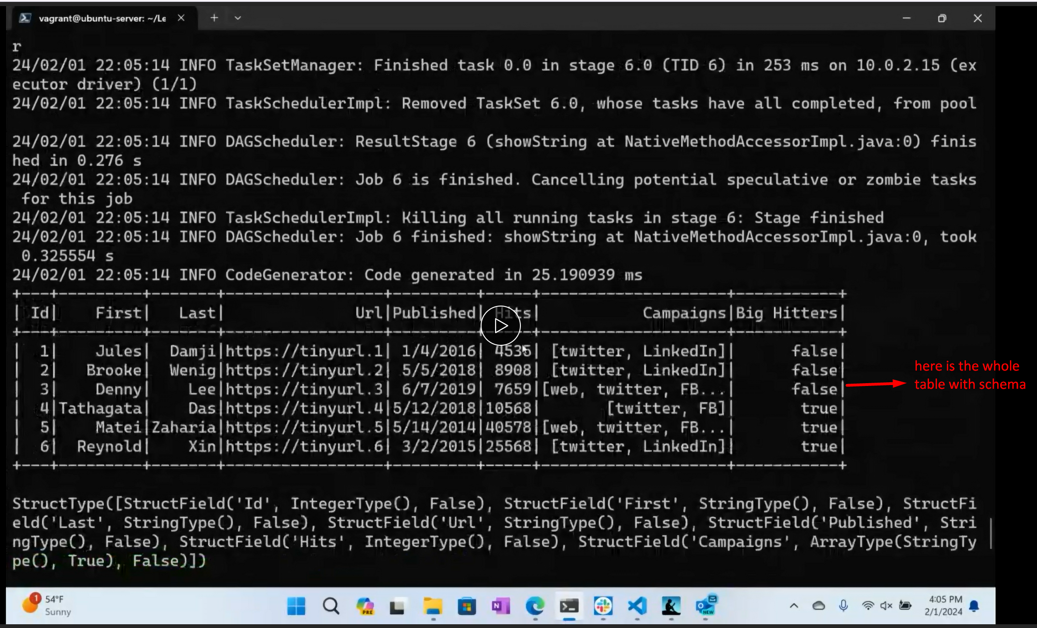

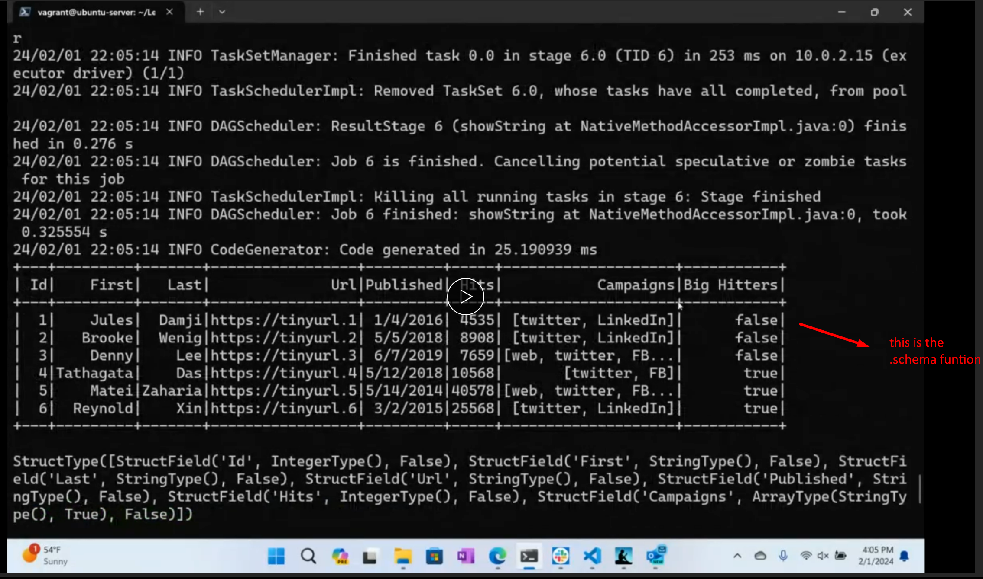 **this is almost at the bottom of the output**

**If we go back to the top of this output…**

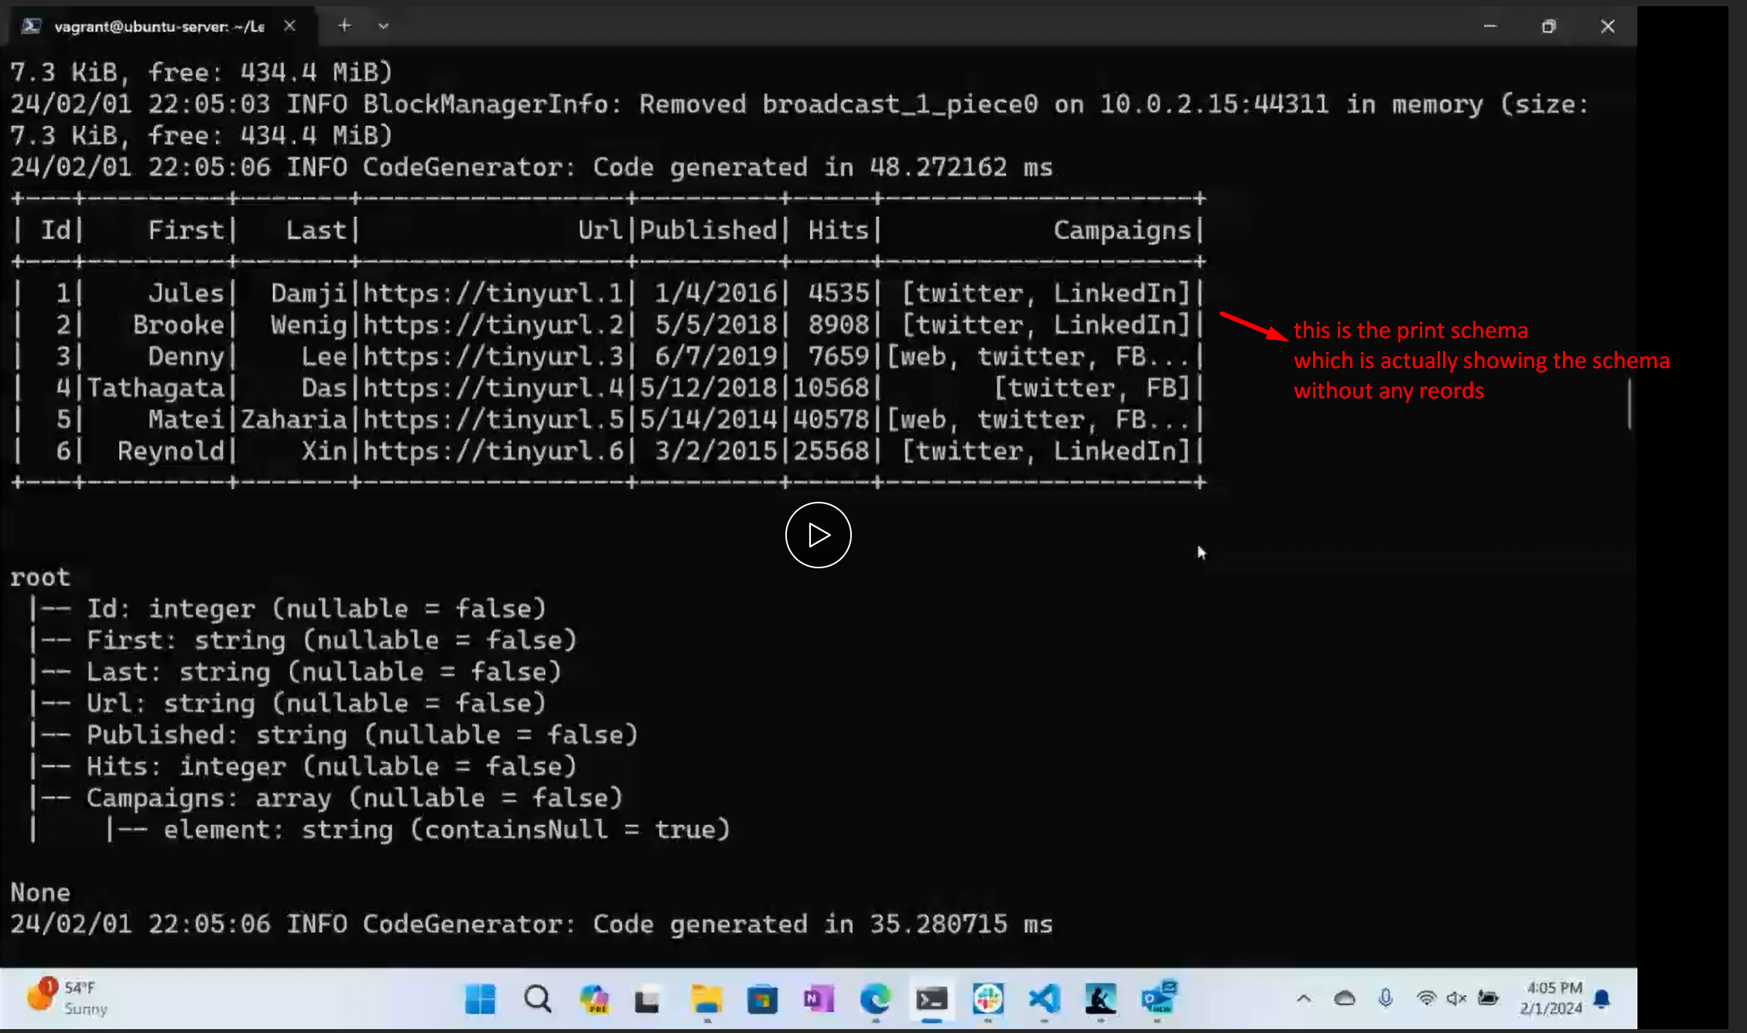

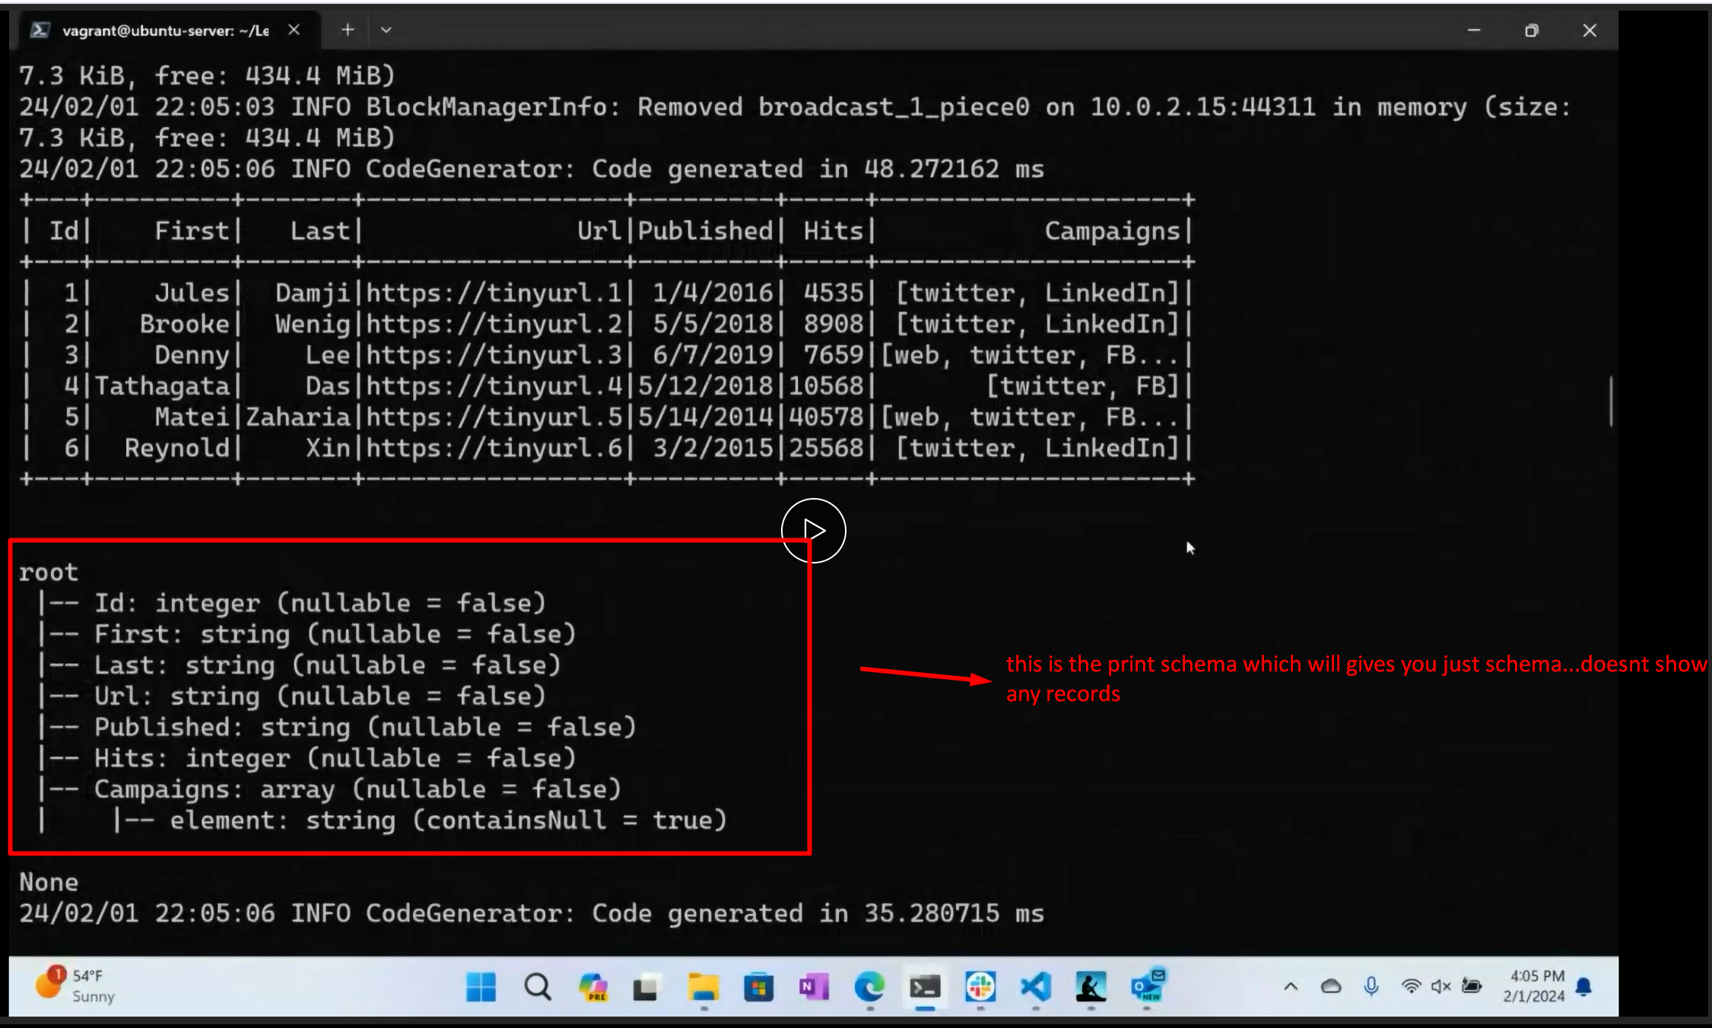

**NOW LETS GO TO ASSIGNMENT LAB 2 52 min**

